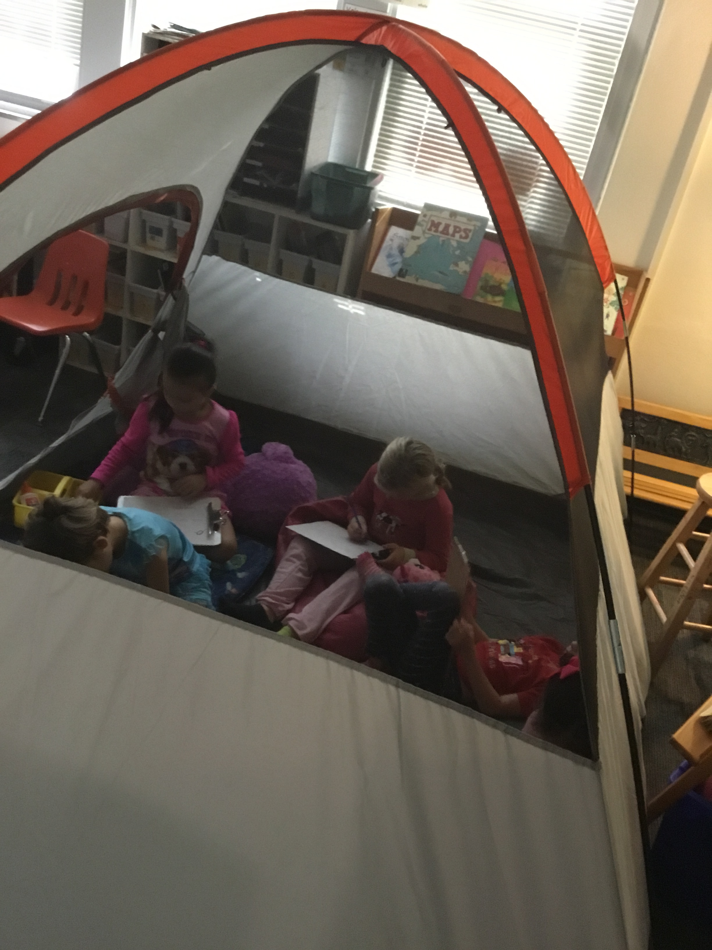 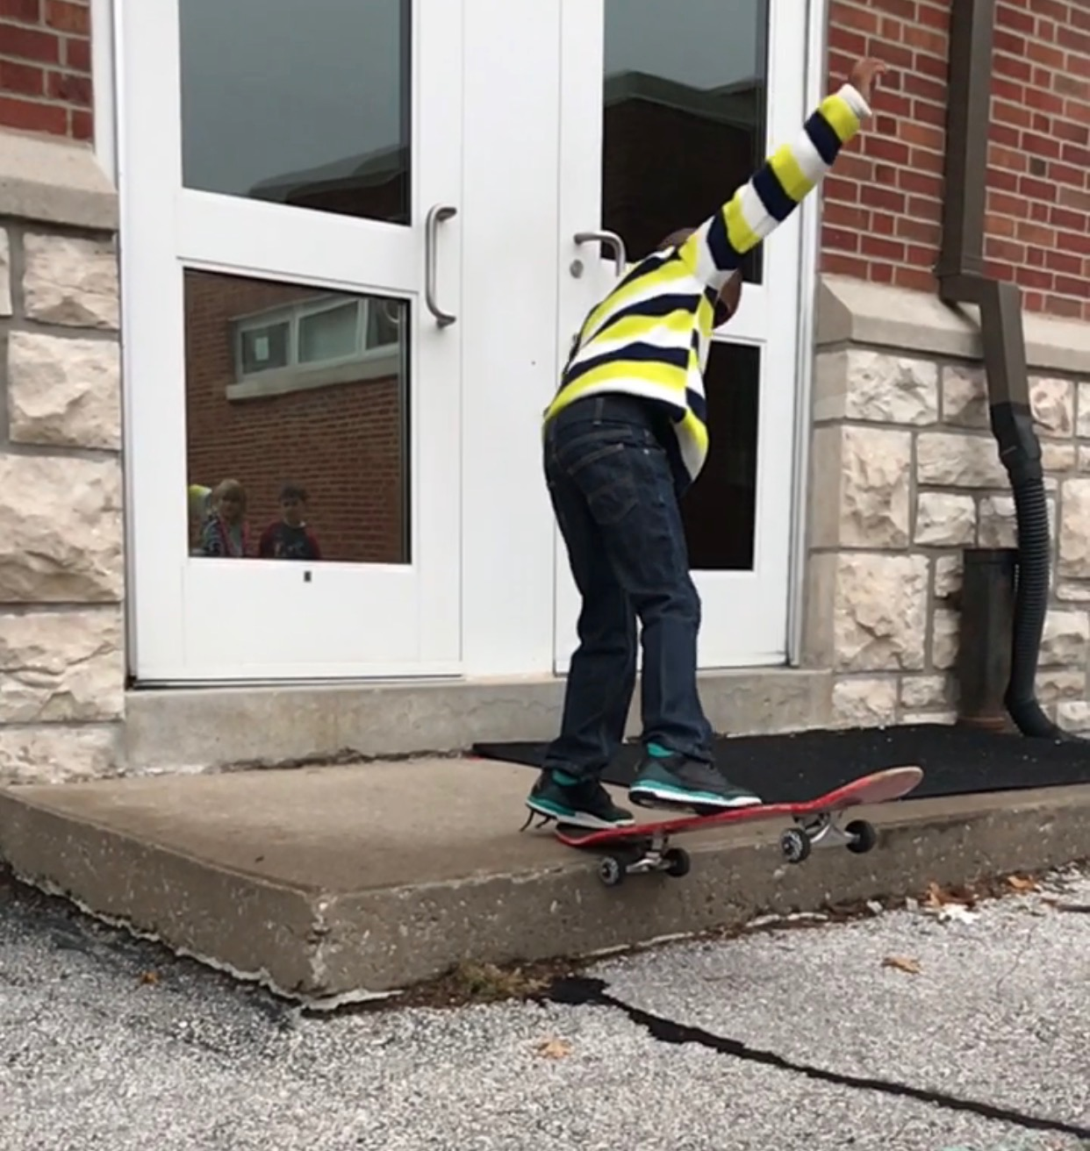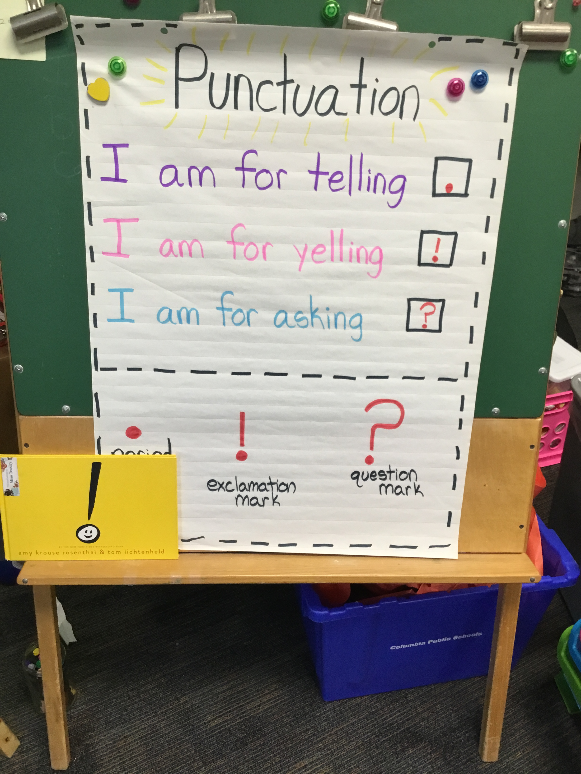

Miss Teasley’s Wedding

Come celebrate with us at Alpine Parks and Gardens. Starts at 4:00

## Upcoming Events

* PTA Movie Night (10/13)
  + PTA is starting a monthly movie night, this month is “Hocus Pocus”. The movie starts at 6:30 in the gym. There will be popcorn and concessions for sale. All proceeds help support our school!
* Picture Retake Day (10/20)
  + Please make sure that you have filled out the form online only if your child was absent on meet the teacher night, or if you want them to receive retakes.

Mile’s Birthday

We cannot wait to celebrate with you!

Dental Clinic

Students will only participate if you filled out the form.

Picture Retake Day

Make sure you have filled out the form online.

Early Release

School lets out at 12:15

29

26

21

20

17

Movie Night

PTA is showing “Hocus Pocus” at 6:30 in the gym.

13

We had a very busy successful week this past week!

We earned a major celebration by making lots of strong choices this week!

Don’t forget we release at 12:10 on Tuesday.

# Kirsten Teasley

# kteasley@cpsk12.org

# missteasleys.weebly.com

# @LeeRoom203

All calendars and newsletters are on our website missteasleys.weebly.com

#### *Don’t forget about our monthly calendar*

### Important Dates

Room 203

The capacity to learn is a gift; the ability to learn is a skill; the willingness to learn is a choice.

-Brian Herbert

In writing we have started talking about different editing practices. We are using post it notes to go back and add more details to our story, as well as punctuation. We have talked about a period, question mark and exclamation mark. Students are making sure that their story has a beginning, middle, and end by “walking through” their stories.

I word work, we are going to move on to the short “I” sounds next week. We will continue to review our short “a” sounds as well.

In our book clubs, we have been discussing the beginning, middle and end of the books we read. This helps students with their retellings of the story and it also creates another connection between our reading and writing times.

In science, we are wrapping up our discussion of sound and light and moving on to our skeletons and muscles. Students will start to bring in recycled materials next week to create instruments on Thursday.

In math, students have been working with different number stories. We are practicing looking for clues to decide if it is an addition or subtraction story. Students are starting to pick up on those key words.

Draeden was our star student this week!

Draeden had a great time being our star student this week!

For his special skill, he showed us some neat tricks on his skateboard. He likes to practice these skills every day.

When he grows up he wants to be a basketball and football player.

His favorite thing to eat is pasta!

Next week’s star student is: Madame!

## Star Student

## What’s Happening in Room 203