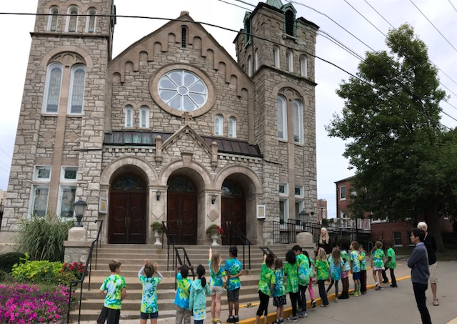 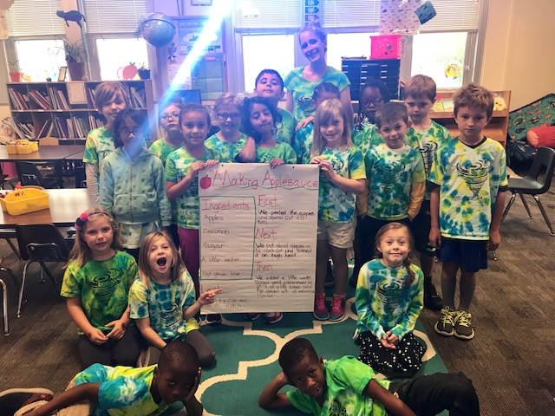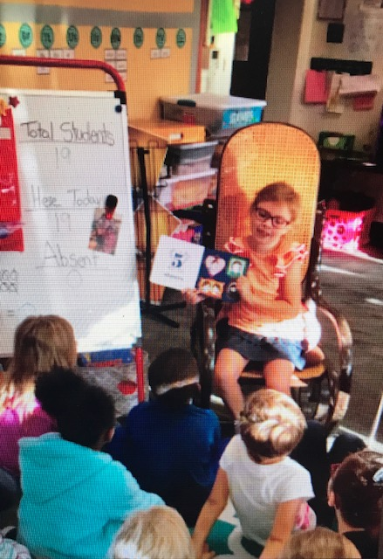

## Upcoming Events

* Daum Field Trip
  + We will head to Sedalia to visit the museum. We will tie in our current science unit of light and sound. If you would like to volunteer on this trip, please let me know if you have not already.
* Fall Festival
  + Our fall festival theme is…. FAIRYTALES! Please see the note in this folder about costume restrictions, as well as the parade route.

Picture Retake Day

Make sure you have filled out the form

Early Release

School lets out at 12:15

Lillian’s Birthday

We can’t wait to celebrate!

Daum Field Trip

We will leave the building at 8 and return at 1

Ibiyinka Workshop

Starts at 6:30 in the gym

20

17

8

6

3

ASB Meeting

Starts at 6 in the Gym/Cafeteria

3

Students had a wonderful week!

We took a walking field trip to look at stained glass. We discussed the difference between transparent, translucent and opaque. This ties in with our current science unit.

# Kirsten Teasley

# kteasley@cpsk12.org

# missteasleys.weebly.com

# @LeeRoom203

All calendars and newsletters are on our website missteasleys.weebly.com

#### *Don’t forget about our monthly calendar*

### Important Dates

Room 203

Never stop learning, because life never stops teaching.

In writing, we have started to create our family books. Students are just writing about their siblings, parents and grandparents. We have also looked at a couple of mentor texts and found evidence of how they brought their characters to life and then attempted to mimic that in their own writing. We will start to look at a narrative checklist with partners in the next couple of weeks.

In our reading groups, we have focused on becoming more confident in our independence. I am coaching all students to focus on the words in front of them, and not to look at me when they come to an unknown word.

In math, students have been working on answering open response prompts. This is quite the challenge because they are used to a very structured way of answering. We will continue to practice this skill and to put our thoughts into writing.

In science, we have started out light and sound unit. Students are starting the unit by creating a musical instrument out of recycled materials. We will create these in the next week. Our main topics are vibrations and light sources.

We will open our visiting animal next week!

Justina was our star student this week!

She shared her special skill with us, which was playing the harmonica. She explained how it is important to make a small hole with your lips so that way your air is only blowing into one of the keys, instead of multiple.

She also shared her favorite book which is *Pride and Prejudice* many other students in our class made the connection that they had the same book in their home.

In her parent letter, we learned a really funny joke..”How does a moon cut its hair?” “ It eclipse it!”

Next week’s star student is: Ali!

## Star Student

## What’s Happening in Room 203