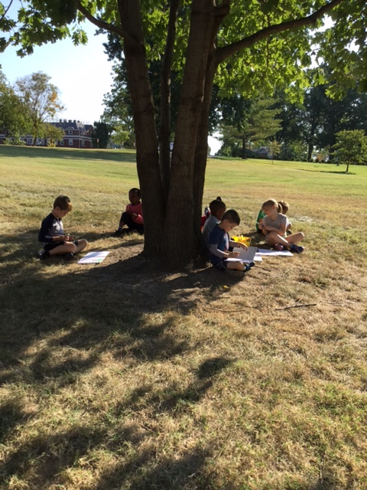 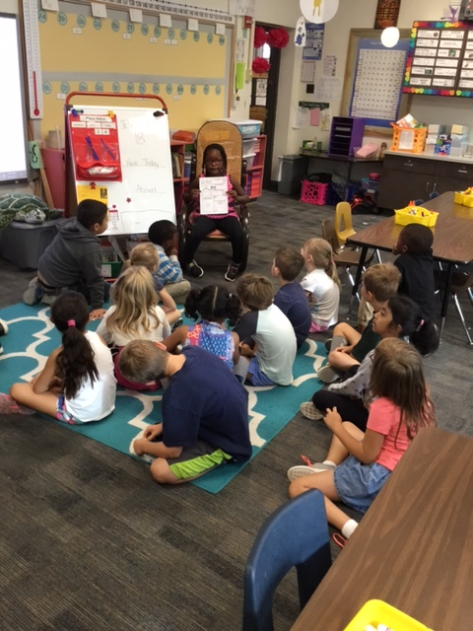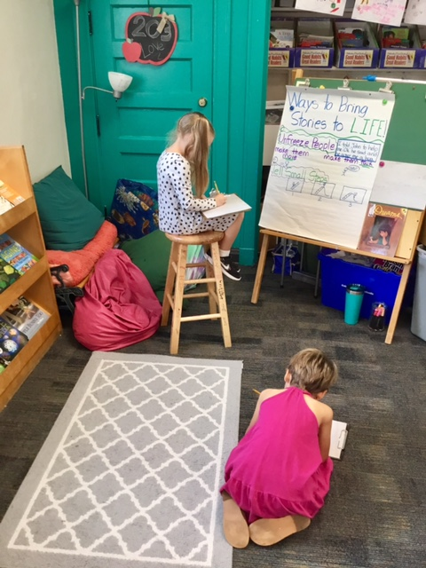

## Upcoming Events

* Read-a-Thon
  + Don’t forget that all pledges are due on 9/26. I have heard lots of students talking about all the reading they are doing at home. Thank you so much for encouraging your child!
* Fall Festival
  + Our fall festival theme is…. FAIRYTALES! Please see the note in this folder about costume restrictions, as well as the parade route.

Lillian’s Birthday

We can’t wait to celebrate!

Daum Field Trip

Please fill out the yellow permission form & send back.

Scholastic Due

Please make sure to have your orders turned in.

Blue’s In Schools

Assembly at 9

Read-A-Thon Due

Make sure to send in their pledge folder!

8

6

29

28

26

No School

Teacher Work Day

25

All of our school shirts have been tie-dyed! I have them at my house now and will wash this early next week.

***I had subs the last 2 days of this week and will have a half-day sub on Tuesday. So I will not do checklists this week.***

# Kirsten Teasley

# kteasley@cpsk12.org

# missteasleys.weebly.com

# @LeeRoom203

All calendars and newsletters are on our website missteasleys.weebly.com

#### *Don’t forget about our monthly calendar*

### Important Dates

Room 203

Be humble, be teachable, and never stop learning.

Sin writing, students have been focusing on unfreezing their characters. They have done this by making their characters move and talk. They have also practiced telling small steps with their words and their illustrations. Lastly, we have started to practice bring the inside out. So they are starting to pay attention to the emotions of their characters and make sure that they portray those emotions to their readers.

In word work, we have completed our first week of short a practice. We will continue with the short a sound next week!

In literacy, students have now received 2-4 new books in their book clubs. We have been focusing on taking picture walks to create predictions about the story and to also helps us solve unknown words.

In math, students have been introduced to subtraction problems. We will continue building our skills with skip counting and addition as well.

In social studies, we have been discussing our family and we will continue to discuss our families. We will also start to talk get into our light and sound science unit.

Our visiting animal was a Sea Turtle!

Angel was our star student this week!

She shared her poster with us and we discovered that she wants to be a vet when she grows up. She wants to focus her practice around household pets ☺

On Tuesday, Angel shared with us a fun story about different Sahara animals and their friendships.

On Thursday, Angel shared her family photos with the class.

Next week’s star student is: Justina!

## Star Student

## What’s Happening in Room 203