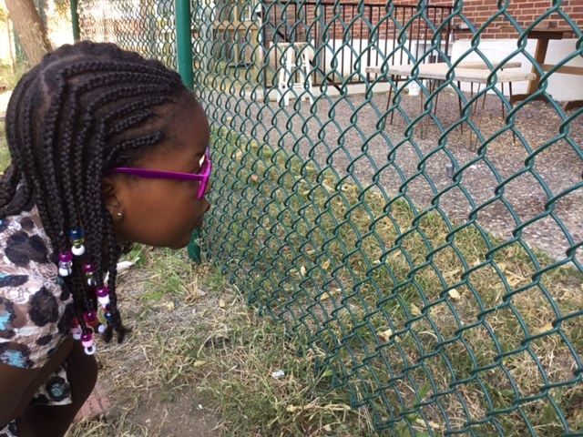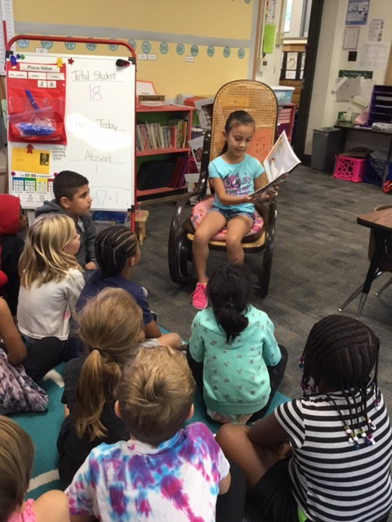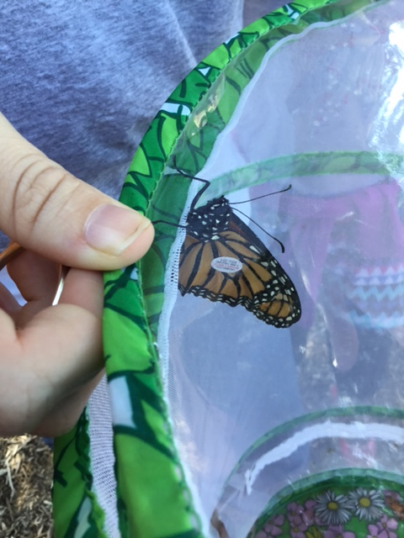

## Upcoming Events

* Slim’s Chicken Fundraiser
  + 9/21 is our first restaurant fundraiser! You can go to Slim’s Chicken at any point during their business hours and let them know that you are there for the fundraiser.
* Read-a-Thon
  + Don’t forget that all pledges are due on 9/26. I have heard lots of students talking about all the reading they are doing at home. Thank you so much for encouraging your child!

Scholastic Due

Please make sure to have your orders turned in.

Blue’s In Schools

Assembly at 9

Read-A-Thon Due

Make sure to send in their pledge folder!

No School

Teacher Work Day

Slim’s Chicken

Fundraiser for our school. All day, just mention Lee Elementary.

29

28

26

25

21

Tie-Dye Day

We will tie-dye the t-shirts that we screen printed.

20

We had a wonderful time screen-printing our school shirts! Every child has at least one shirt, and we will tie-dye it next Wednesday at 10. We would love to have parent volunteers!

Our caterpillar friend turned into a butterfly this week.

# Kirsten Teasley

# kteasley@cpsk12.org

# missteasleys.weebly.com

# @LeeRoom203

All calendars and newsletters are on our website missteasleys.weebly.com

#### *Don’t forget about our monthly calendar*

### Important Dates

Room 203

“Discipline is the bridge between goals and accomplishment.”

-Jim Rohn

Students have been focusing their writing on creating leads that “hook” their readers. I introduced three different types of leads: Sound, Question, and Talking. The sound lead is currently a favorite in our classroom!

In word work, students will continue to focus on their short vowel sounds. We will start to do word work sorts next week. This is a great hands on way to learn the different letter sounds.

In our book clubs, we have been focusing on talking about our reading. I like to ask them about their favorite part and why that is their favorite part. Some students are practicing how to write about what they read. Students are constantly practicing their retellings with the language “first, next, then, last”, this shows me that the child has comprehended the text that they read.

In math, students are continuing to practice different counting strategies as well as counting on. Counting on can be difficult for students, but we are practicing this skill through games, so it makes it more seamless.

In science, we will start our light and sound unit. The students are going to LOVE this unit!

Lilly was our star student this week!

Lilly brought in her favorite book, *When The Rain Came Down,* to share with the class. All of our students thought it was a hilarious book!

Lilly also performed a quick demo of her amazing tap-dancing skills! The kiddos were super impressed with it! This video is on our twitter page ☺

On Thursday, she taught us more about her family and then on Friday, we were able to read a very sweet letter that her father wrote to give our class more information about her!

Next week’s star student is: Angel!

## Star Student

## What’s Happening in Room 203