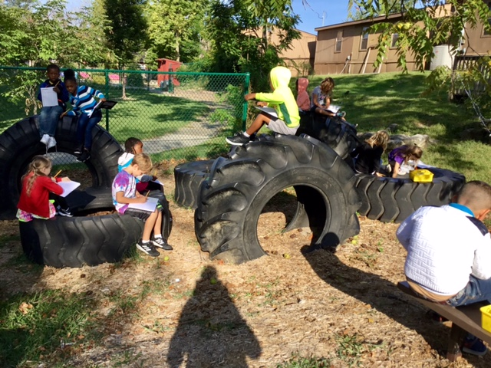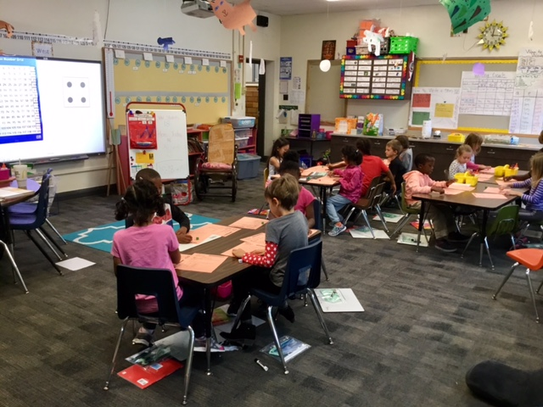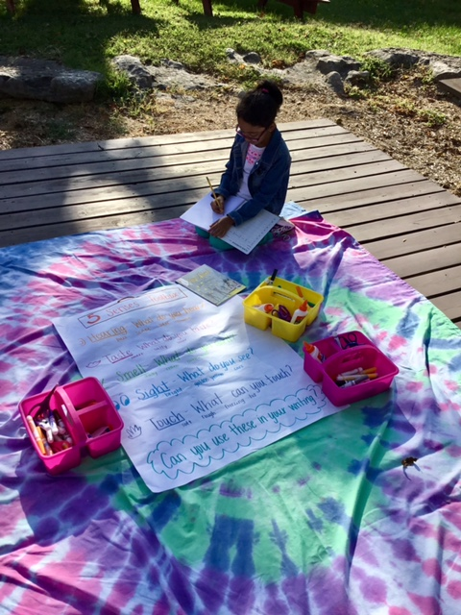

## Curriculum Night (9/14)

Curriculum night will take place on September 14th. There are two different presentation times that you may go to. We do it this way so that you can attend another grade level’s presentation if you have more than one child that attend Lee. The first presentation is 6:00-6:30 and the second presentation is 6:30 to 7:00.

First grade will present about the different units we teach, as well as some homework specific information. You will also receive information about what the learning expectation is for each grade level. This is a great opportunity for you to come and ask us any questions.

Please let me know if you have questions.

Tie-Dye Day

We will tie-dye the t-shirts that we screen printed.

Dayvin’s Birthday

We all hope you have a wonderful day! We cant wait to celebrate!

Curriculum Night

Lee Elementary

6:00-6:30 or 6:30-7:00

Screen Printing Day

Make sure your child has a white shirt to screen print on.

PTA Meeting

Lee Elementary library at 6:00.

Let me know if you need info.

20

15

14

13

12

Lilly’s Birthday!

We all hope you have a wonderful day! We cant wait to celebrate

9

Next week we screen print our white t-shirts! We are scheduled to screen print at 10 on Wednesday. Feel free to come volunteer and help out!

Curriculum night is Wednesday; I hope to see everyone at one of the sessions!

# Kirsten Teasley

# kteasley@cpsk12.org

# missteasleys.weebly.com

# @LeeRoom203

All calendars and newsletters are on our website missteasleys.weebly.com

#### *Don’t forget about our monthly calendar*

### Important Dates

Room 203

In writing, students are focusing on adding details to their narratives. I have introduced the “5 Senses Toolbox” which reminds them of their five senses and how you can create sensory details with them. We are also making sure that we are stretching out unknown words and making sure that there is a vowel in every word.

In word work, we will continue to focus on short vowel sounds. This will be the same for the next few weeks.

During our literacy block, I have been able to assess each student one-on-one for his or her reading level. I was actually able to hold our first book club session on Friday! So all of the students now have a book that is at their level, in their book box. Students will also have a book in their homework folder that they can practice reading.

In math, we are wrapping up our first unit. This is a spiral curriculum, so we will continue to come back to all the topics we have discussed. Students are learning how to use our number chart, and have learned some games to help reinforce this knowledge.

In social studies, we are starting to talk about our families and the role that we have within our family and within other communities.

We will continue to write narratives next week, but we will have our famous “watermelon lesson” I will make sure to tell you all about it in our next newsletter.

Students will meet with me in small groups, everyday to focus on different reading skills and tools. This is one of my favorite things to teach, so I am so excited that I was able to get everything set-up this week!

In math, we will take a unit assessment and then start unit 2. More info will be sent home in next week’s Friday Folder.

In social studies, we will continue to talk about our role in different communities (school, home, Columbia, etc.)

## Where We’re Headed

## What’s Happening in Room 203

“Allow yourself to be a beginner. No one starts off excellent.”