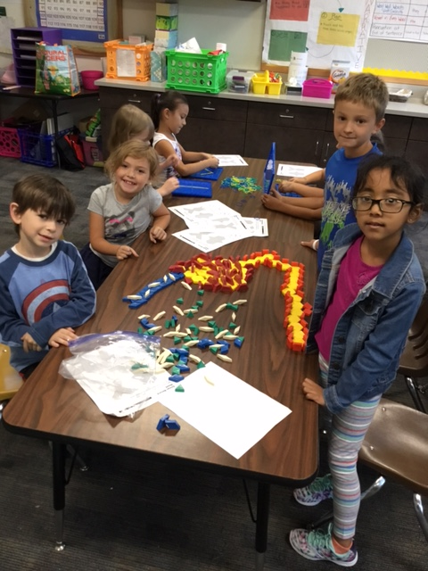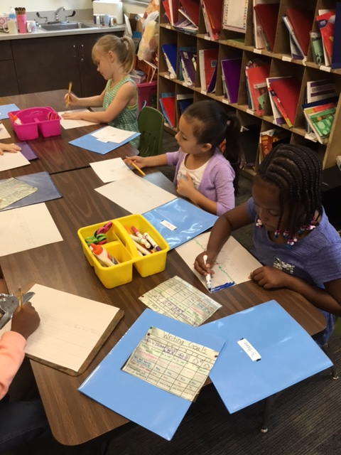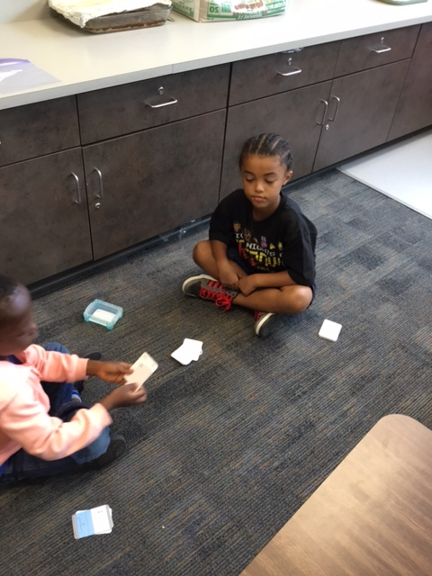

## Curriculum Night (9/14)

Curriculum night will take place on September 14th. There are two different presentation times that you may go to. We do it this way so that you can attend another grade level’s presentation if you have more than one child that attend Lee. The first presentation is 6:00-6:30 and the second presentation is 6:30 to 7:00.

First grade will present about the different units we teach, as well as some homework specific information. You will also receive information about what the learning expectation is for each grade level. This is a great opportunity for you to come and ask us any questions.

Please let me know if you have questions.

Dayvin’s Birthday

We all hope you have a wonderful day! We cant wait to celebrate!

Curriculum Night

Lee Elementary

6:00-6:30 or 6:30-7:00

Screen Printing Day

Make sure your child has a white shirt to screen print on.

PTA Meeting

Lee Elementary library at 6:00.

Let me know if you need info.

Lilly’s Birthday!

We all hope you have a wonderful day! We cant wait to celebrate!

15

14

13

12

9

No School

It is Labor Day, so school will not be in session.

4

We had such a wonderful week! I cannot believe we are going to be starting our fourth week together!

Students have been working on building up their amount of focusing time. They are doing great with reading silently for 20 minutes!

# Kirsten Teasley

# kteasley@cpsk12.org

# missteasleys.weebly.com

# @LeeRoom203

All calendars and newsletters are on our website missteasleys.weebly.com

#### *Don’t forget about our monthly calendar*

### Important Dates

Room 203

Students are currently learning how to write narratives. They have learned that it has to be a true moment that has already happened in their life. We spent a lot of our time this week looking at our criterion chart for writing. This allows students to set goals for their own writing to make it even better. They all have a personal copy of this chart.

In word work, we have just started our discussion on vowels. I chose to start everyone off with vowels this year, because our writing chart requires students have to have a vowel in every word. Over the next few weeks, we will spend longer amounts of time discussing each vowel and it’s specific short vowel sound.

In science, we have been discussing how to keep ourselves and others healthy. We have focused on hygiene and how to take care of your nose. We created “booger ghosts” and discussed why it is important to wash your hands. We also had a “glitter germs’ day on Friday. I put glitter on 5 students’ hands at the beginning of the day. Throughout the day we notice that glitter starts to appear on bathroom passes and things we all touch. We then talk about how germs are spread. We will do a hand-washing lesson with our nurse next week.

Next week, we will continue to write narratives and read model text. This helps children become inspired to create their own narratives and mimic some of the things they noticed the author or illustrator did.

We will continue to discuss our short vowel sounds during our word work time.

Students will start to practice rotating through quiet stations, during our reading block. This allows me to teach specific reading skills to small groups of children.

In math, students will continue to learn about skip counting and tally marks. They will also learn a couple fun games!

In social studies, we will start to discuss our roles and rules of our family dynamic.

## Where We’re Headed

## What’s Happening in Room 203

Everyone you will ever meet knows something you don’t.

-Billy Nye