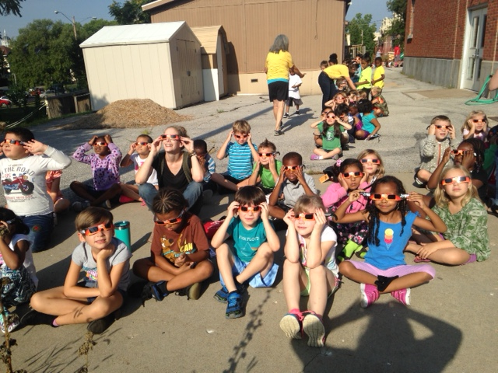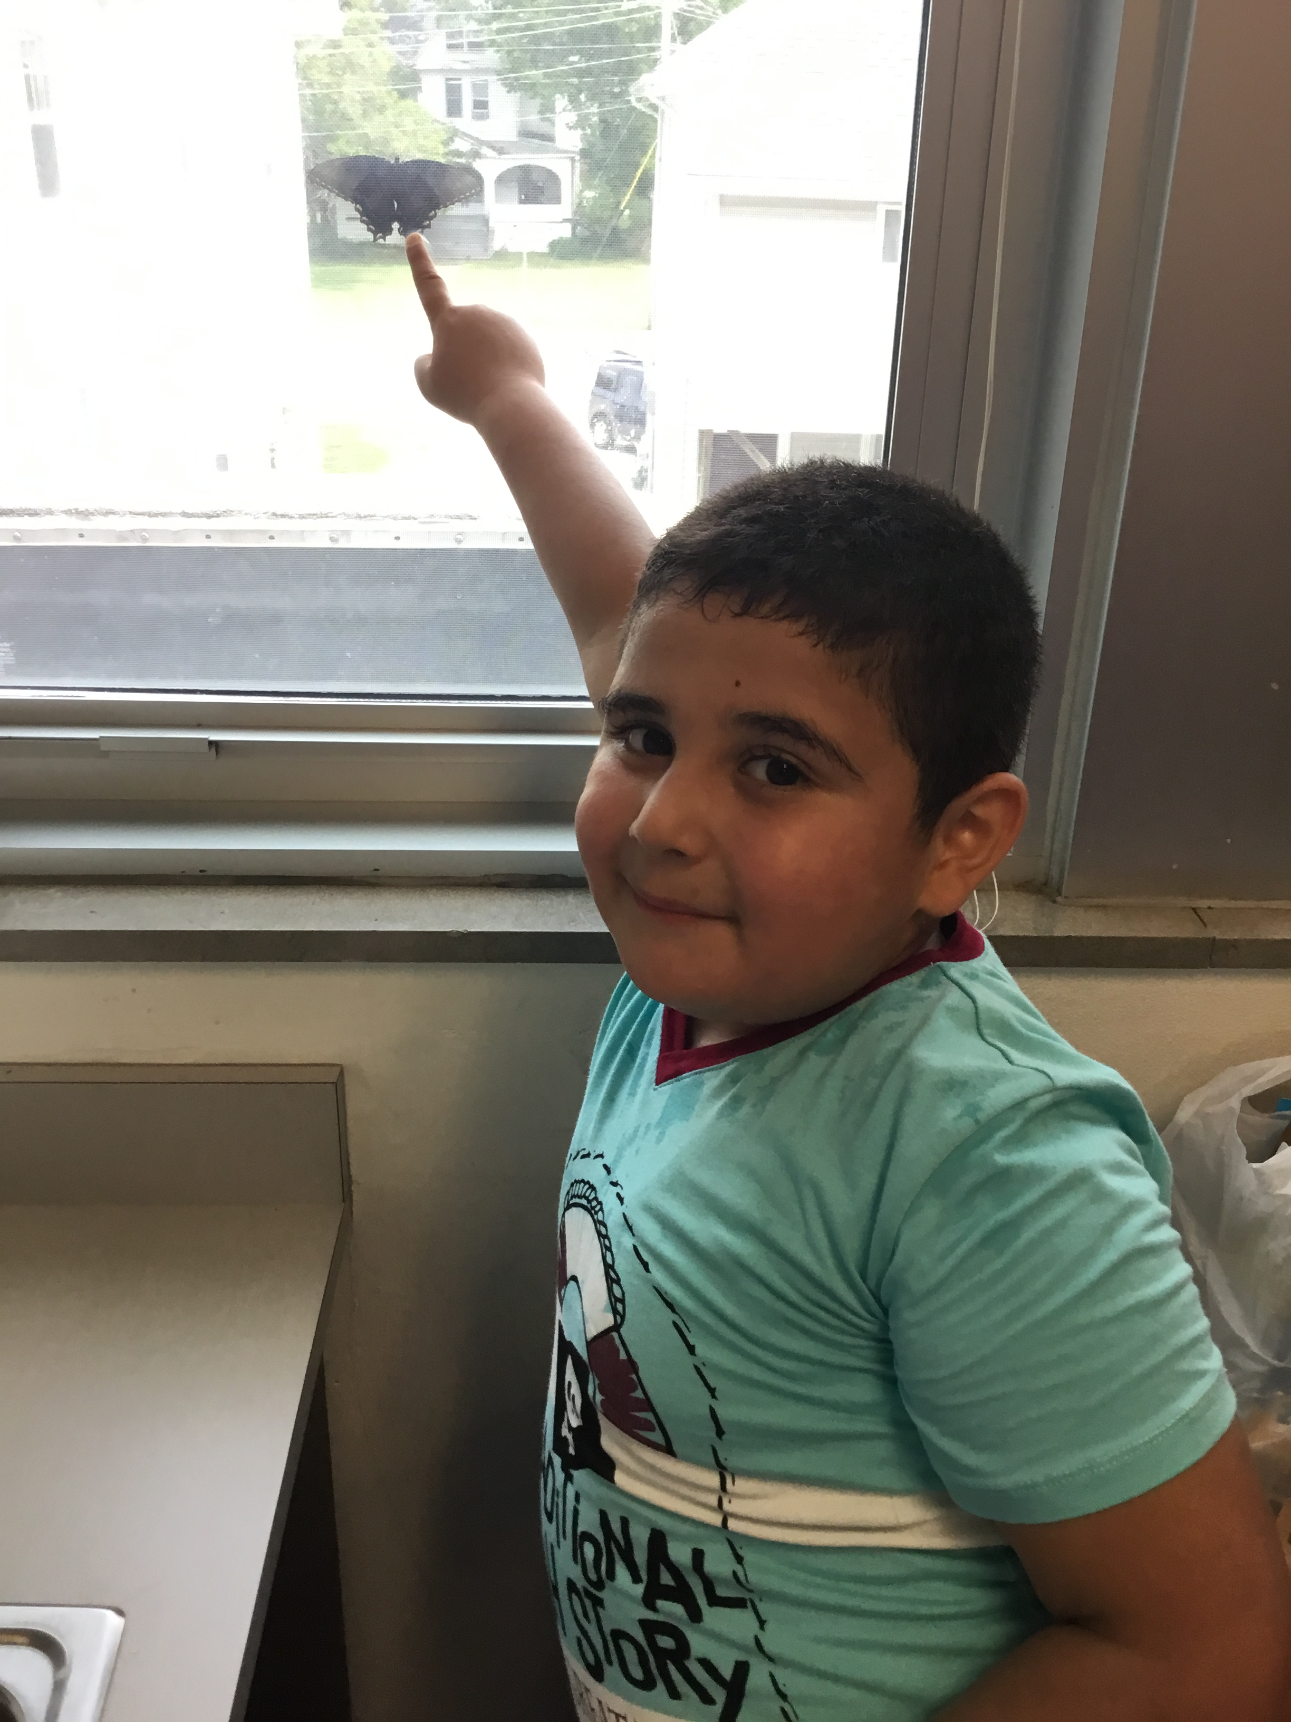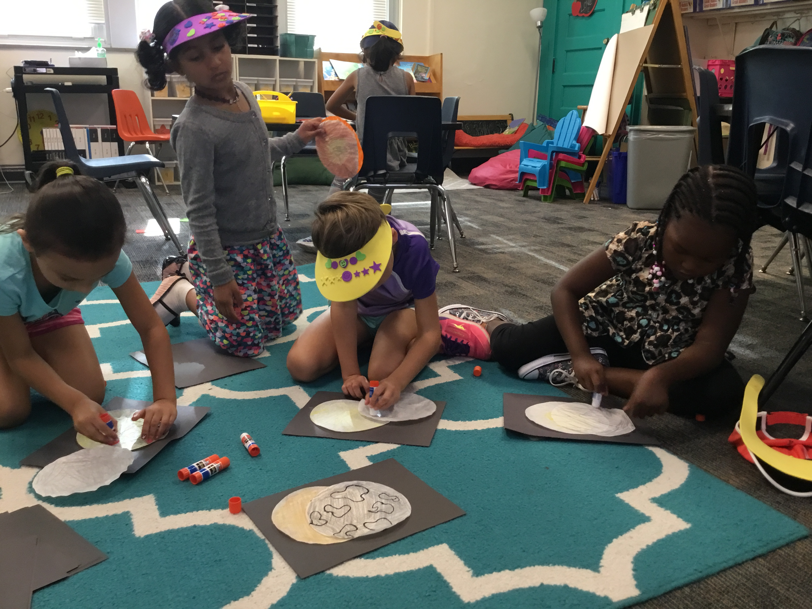

## The 411

September is going to be a very busy month and it is our first full month together! I wanted to spend a little more time letting you know about some important events and how to access our calendars and newsletters if you happen to misplace your paper copies ☺ I will always post our calendar and newsletters onto our classroom website (missteasleys.weebly.com). Screen-printing and tie-dye day are quickly approaching! Please make sure that you have sent in a white t-shirt for your child. Our 5th graders create a t-shirt design that every child then screen prints onto their own shirt. Students will then be able to tie-dye their t-shirt. **Screen Printing: September 13th Tie-Dye: September 20th.**

Screen Printing Day

Make sure your child has a white shirt to screen print on.

PTA Meeting

Lee Elementary library at 6:00.

Let me know if you need info.

Lilly’s Birthday!

We all hope you have a wonderful day! We cant wait to celebrate!

No School

It is Labor Day, so school will not be in session.

“My Outdoor Spot” Due

This assignment when come home once a month.

13

12

9

4

1

“My Outdoor Spot”

Please make sure to read instruction sheet.

28

So the Solar Eclipse was absolutely amazing…It is something I will never forget. Our students did such a wonderful job with observing the eclipse and allowing everyone around them to do the same. If your child was not here and is talking about some of the activities we did, let me know and I can send stuff home for you!

##### Our class during the “eclipse drill”

# Kirsten Teasley

# kteasley@cpsk12.org

# missteasleys.weebly.com

# @LeeRoom203

All calendars and newsletters are on our website missteasleys.weebly.com

#### *Don’t forget about our monthly calendar*

### Important Dates

Room 203

Next week, we will begin our word study. We will start with our short vowel sounds. I believe that it is important to start with the vowel sounds because I always remind students that every word has a vowel. We will create small art pieces to show our understanding of each short vowel sound.

We will be starting our germ unit next week. Students will learn about how germs are passed on and how to prevent one another from getting sick. We will read some fun books and learn how to make a “booger ghost” (it involves a tissue).

## Where We’re Headed

## What’s Happening in Room 203

I have no special talent. I am only passionately curious.

-Albert Einstein

Students have been reviewing different expectations this week! On Wednesday, we were able to get on a bus and review the bus expectations with Mr. Elsea. Shortly after that we took a very short walk to practice and review our walking field trip expectations. The students were very successful with both of these challenges! I cannot wait to go and explore with this group!

We have started our narrative writing unit! Students have been discussing what quality writing looks like and how they can challenge themselves to become better writers. Students will continue to write narratives while receiving mini-lessons everyday. Students will be coached to shorten the amount of time each story covers. This allows for more details and focus.

In math, students are practicing using their number line skills with different games. Students have also worked in groups to come up with as many counting strategies as possible. I have been really impressed with their cooperation skills while tackling these challenges.