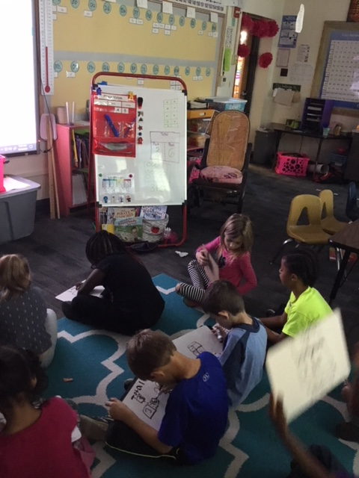 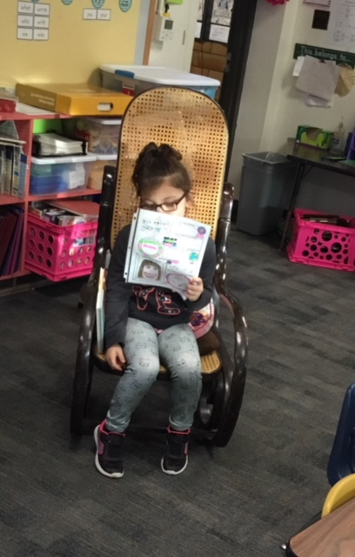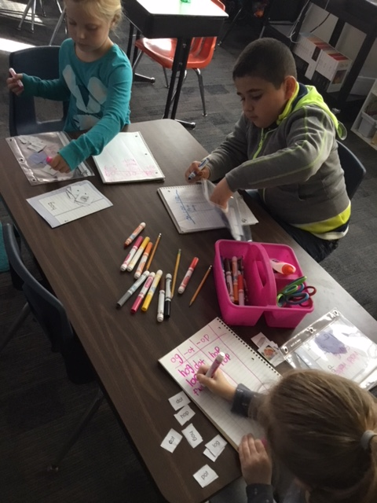

Daylight Savings Ends

“Fall Back”

## Upcoming Events

* Fall Festival
  + Tuesday, October 31st is our fall festival. The first grade them is “fairytales”. Please make sure that you send your child to school in a fairytale themed costume! Please no weapons.
* Parent Teacher Conferences
  + 11/6 – 11/9 If you have not signed up for a conference, please email me. We will meet for 20 minutes to go over your child’s academic ability.

No School

Teacher Work Day

Parent Teacher Conferences

Email me if you have not scheduled yet.

Fall Festival

Don’t forget your homemade fairytale costume!

No School

Teacher Work Day

10

6-9

5

31

30

Mile’s Birthday

We cannot wait to celebrate with you!

29

Students had another great week!

It has been a lot of fun listening to them transition to my “new” name!

Thank you again for all of the well wishes on my new marriage!

# Kirsten Teasley

# kteasley@cpsk12.org

# missteasleys.weebly.com

# @LeeRoom203

All calendars and newsletters are on our website missteasleys.weebly.com

#### *Don’t forget about our monthly calendar*

### Important Dates

Room 203

Education is not the learning of facts;

But the training of the mind to think.

-Albert Einstein

Students have now walked through many different stories, including some of their own narratives. This is helping them understand the way books are set up, as well as how to hook your reader. We will continue to revise and edit our narratives. We are getting close to publishing our first piece in first grade!

In book clubs, students have been building different skills. All groups have been working on their retelling of stories. I made the connection that you just have to “walk through” the story with important details. This was a very strong connection for our students!

They have been focusing on short “I” sounds this week. Some students are working on different sorts and meeting with me a couple of times a week.

In math, students have started the third unit. They are becoming flexible with the open response problems and what is needed from them during those times. I am very impressed with our students!

In science, we are talking about our bones and muscles. We are working on creating a large paper skeleton that is attached by brads. We will reference this skeleton when we discuss the different types of joints in our body.

We did not have a star student this week, but we did not have a newsletter for Madame last week either ☺

Madame was our star student last week!

Madame shared lots of family photos with us and told us all about her siblings and how she helps take care of her little sister.

Madame’s special skill was playing the ukulele. She connected it to our sound science unit by showing her peers the strings vibrating! I was very impressed with this connection.

Next week’s star student is: Cc

## Star Student

## What’s Happening in Room 203