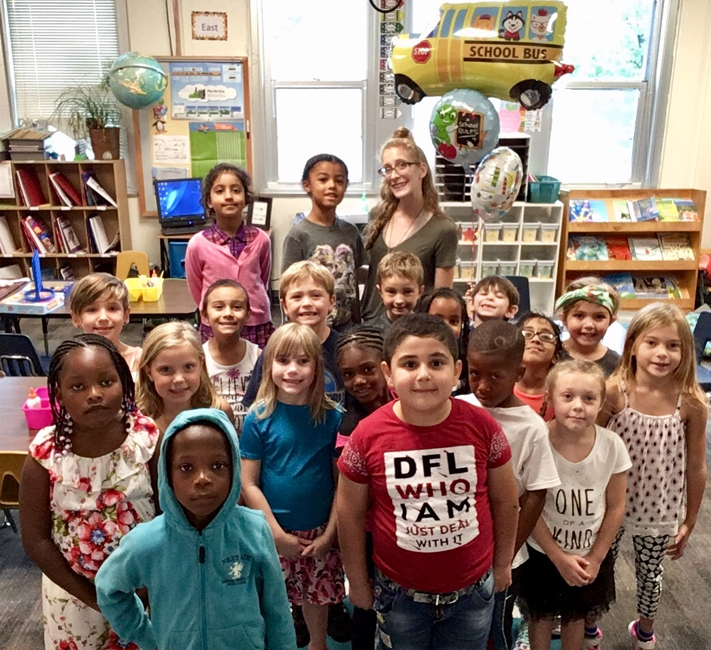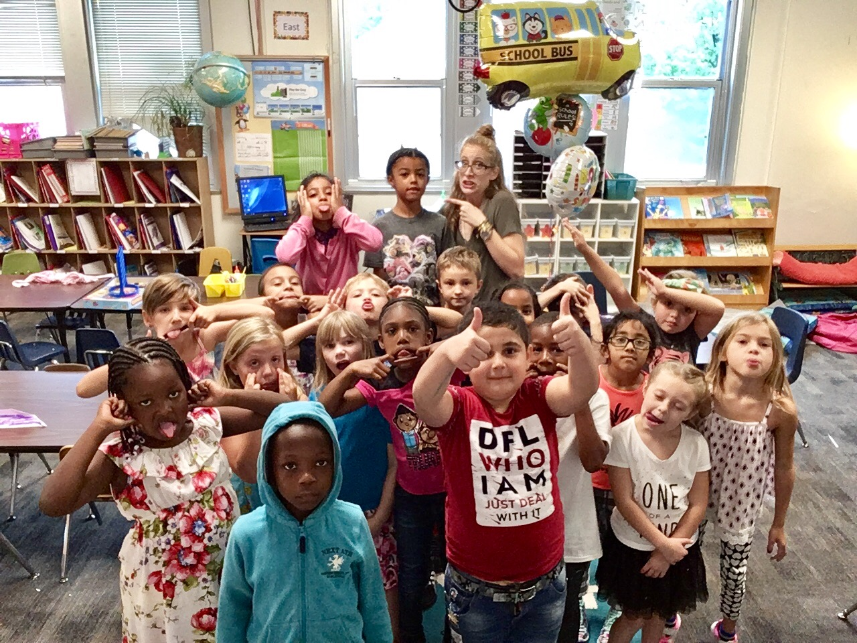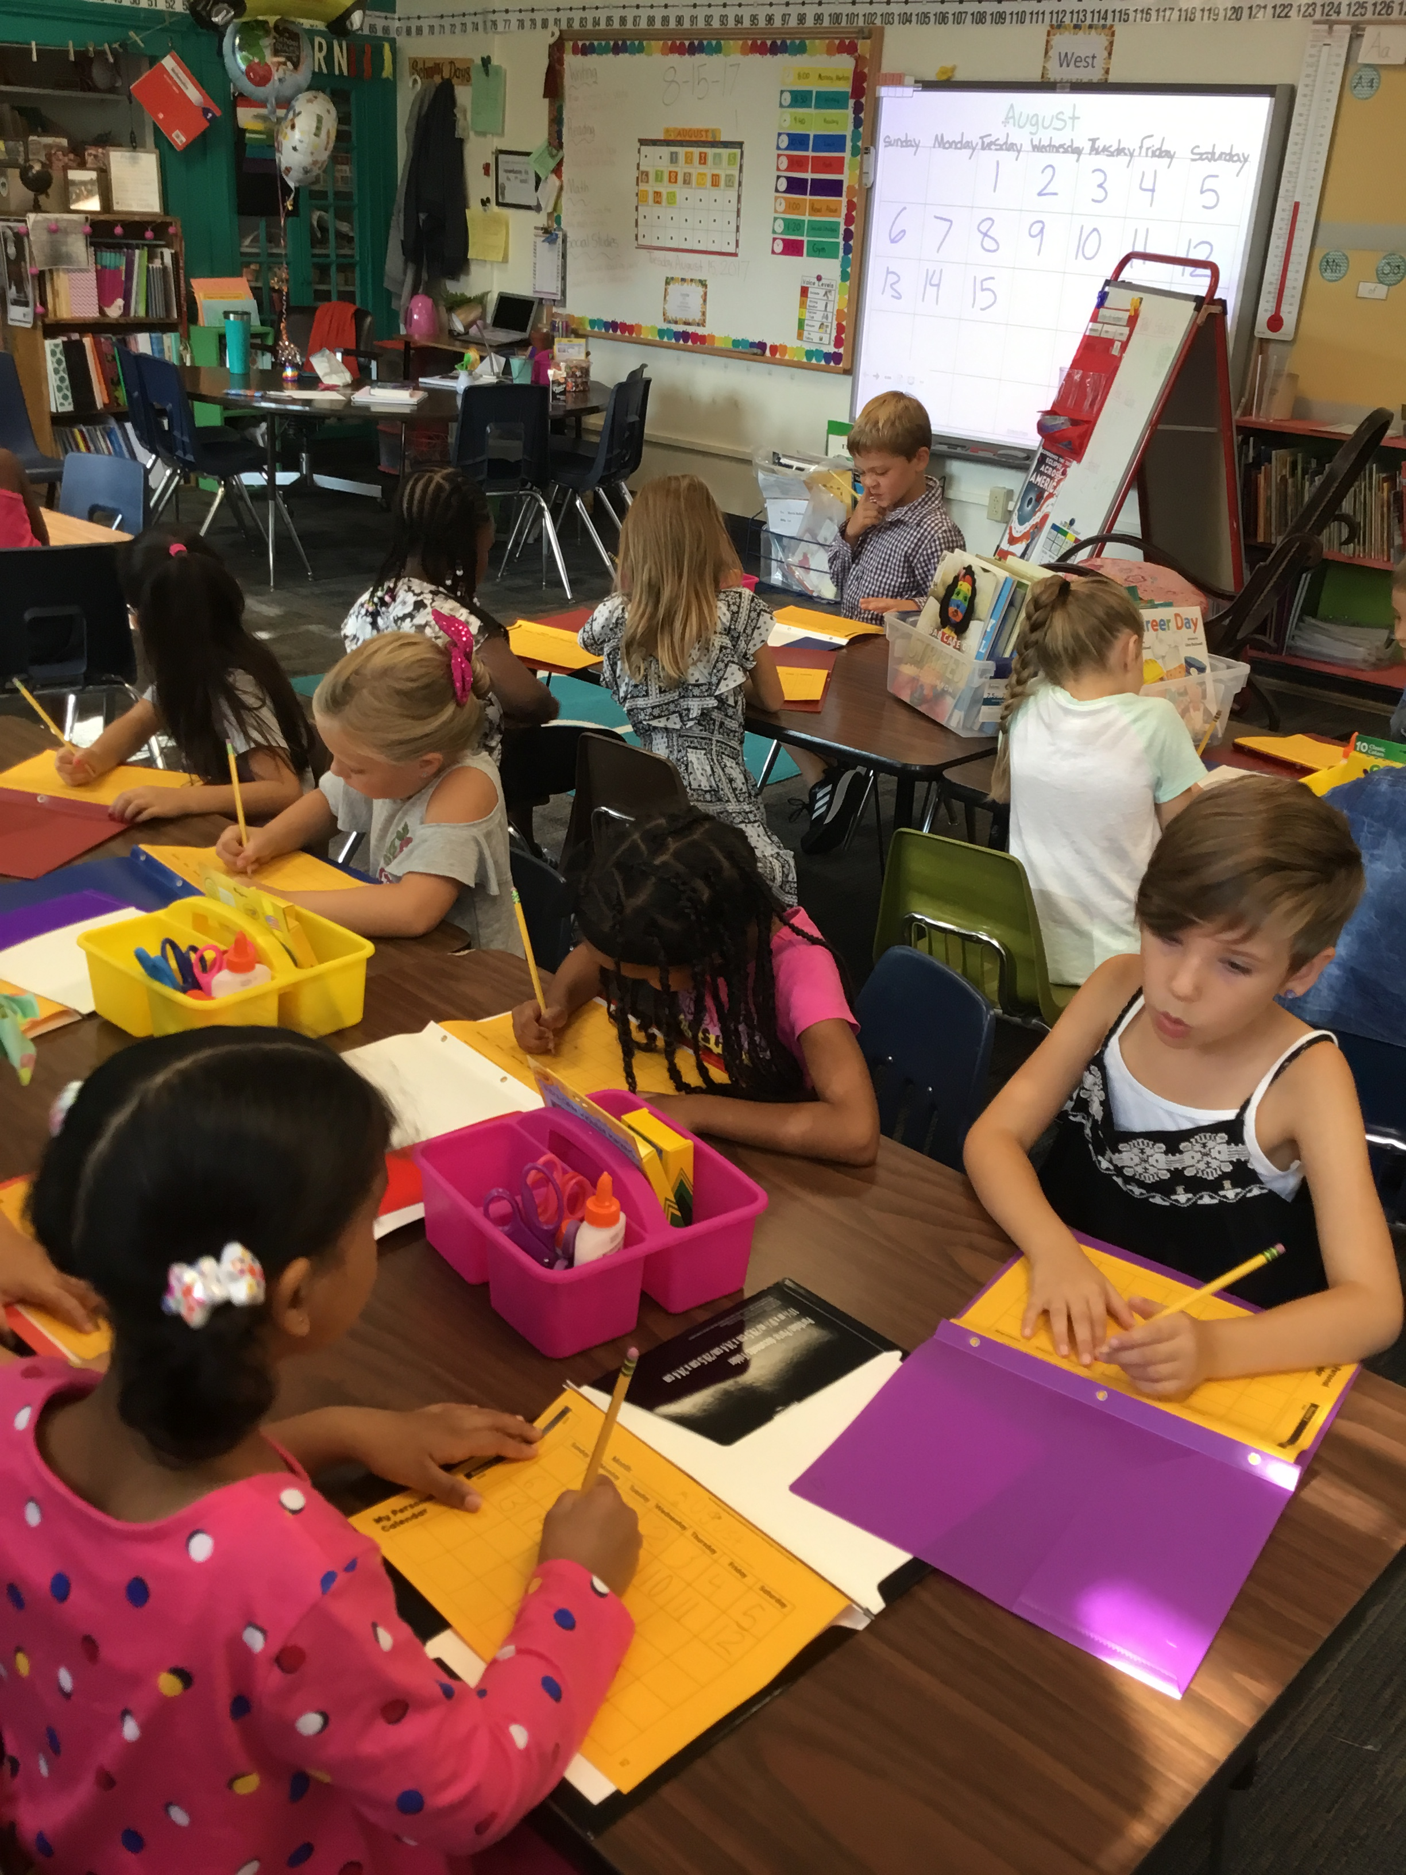

## The Actor’s Toolbox

The Actor’s Toolbox is a “toolbox” full of different skills that will help your child be successful both in and out of the classroom. The first tool in their toolbox is their body. We have talked about what focusing our body looks like in lots of different locations of our building. We are practicing our body control through playing “Simon Says”. Students have been introduced to our voice level system (0-4) and know what each level sounds like. The third tool is their imagination and we talk about controlling our imagination with concentration (our fourth tool). Students play the concentration game. Lastly, we are discussing cooperation, which is a skill we will build through a grouping game next week.

No School

It is Labor Day, so school will not be in session.

“My Outdoor Spot” Due

I will hold on to these and make a book of every month for your child.

“My Outdoor Spot”

Please make sure to read instruction sheet.

“Me Bag” Due

Feel free to send the bag if its completed before Friday.

“Me Bag” Goes Home

Look for homework folder in backpacks on Monday. Due Friday.

4

1

28

25

21

Solar Eclipse

Students must have permission slip signed to go outside during eclipse.

21

These past four days have been a blast!

I have truly enjoyed learning about your child and seeing glimpses of their academic capacity. This year is going to be fantastic!

Please do not hesitate to contact me for any reason!

##### Our 1st class selfie on the 2nd day of school!

# Kirsten Teasley

# kteasley@cpsk12.org

# missteasleys.weebly.com

# @LeeRoom203

All calendars and newsletters are on our website missteasleys.weebly.com

#### *Don’t forget about our monthly calendar*

### Important Dates

Room 203

Next week, we will kick-off our narrative writing unit. This fits seamlessly with the beginning of the school year because it teaches/encourages kids to write about small moments of their life. We will focus our discussions on providing details.

Students will also take a “spelling inventory” they will take this 2-3 times this year to show growth. It measures your child’s understanding of different letter patterns and sounds. Our word study for the rest of the year will be catered to your child’s individual needs.

In math, students will continue to receive more tools for their math tool kit. This helps students to think critically about what tools they choose to use and what the purpose of that specific tool is.

## Where We’re Headed

## What’s Happening in Room 203

“Be somebody who makes everybody feel like a somebody.”

-Kid President

This week, we have focused on building relationships as well as setting expectations.

Students have been building their relationships through playing different games. One of our favorites is the “Connection Chain Game”. Students have also had puzzle time, which challenges them to work cooperatively and pushes their abstract thinking ability. Students have also completed different writing prompts that they then have the opportunity to share. These prompts encourage them to use their imagination and also tell us something about themselves. We will continue to share our stories throughout the whole year, but it will be a focus again next week. Next week’s “homework” will focus on your child being able to share things about themselves, with the class.

We have been visiting different locations within our school so that we can discuss and practice different expectation in each place. Students have also compiled a list of things that they can do to be safe, responsible and respectful while in our classroom.

In math, students have been using the number line to practice skip counting.